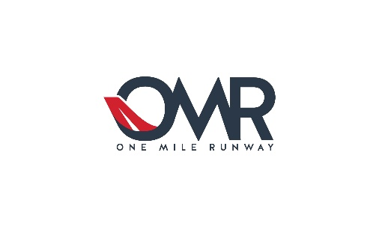
www.flyomr.com

As of: March 3rd, 2025

Griffin Aero (N700ND (TBM))
Plane Share Available | 40% (120 flight hours annually)
Q1 2025 Plane Valuation | $1,766,037
2025 Annual Fixed Costs | $153,382
2025 Annual Variable Costs | $71,750

Pegasus, LLC (988C (TBM))
Plane Share Available | 15% (45 flight hours annually)
Q3 2024 Plane Valuation | $1,831,263
2024 Annual Fixed Costs | $154,882
2024 Annual Variable Costs | $71,750

Thor Aero, LLC (N527VK (PC-12))
Plane Share Available | 10% (30 flight hours annually)
Q3 2024 Plane Valuation | $4,645,553
2024 Annual Fixed Costs | $198,886
2024 Annual Variable Costs | $92,500

Thunderhawk, LLC (Cessna Citation CJ4)
Plane Share Available | 15% (45 flight hours annually)
Q1 2025 Plane Valuation | $2,798,638
2025 Annual Fixed Costs | $225,327
2025 Annual Variable Costs | $126,250

Cirrus SR22 Turbo (See Executive Summary)
Plane Share Available | 70%
Q1 2025 Plane Valuation | -
2025 Estimated Annual Fixed Costs | $63,500
2024 Estimated Annual Variable Costs | $22,500

